WEEK 5: RISK
***
Part 1: Social Interaction (3’)
Let’s talk about dangerous sports:
1. Do you enjoy dangerous sports?
2. How do you prioritize safety while participating in dangerous sports?
3. Have you encountered a situation where the risks of a dangerous sport gave you second thoughts?

Let’s talk about risk:
1. Have you ever taken a risk that led to significant personal growth?
2. Are there any strategies you follow to manage risks?
3. Are you willing to step out of your comfort zone?

Part 2: Solution Discussion (4’)
Situation: You are planning an adventurous travel experience in Vietnam. There are 3 options: exploring the rugged beauty of Ha Giang; conquering Fansipan, the roof of Indochina; or kayaking and island hopping in Halong Bay. Which one do you think is the best choice? What are the reasons for your choice?

Part 3: Topic Development (5’)

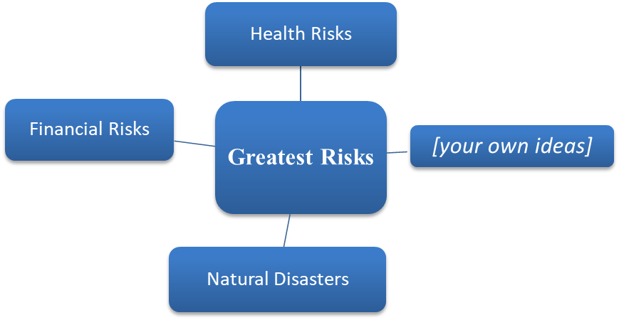
Topic: The greatest risks that people face in everyday life

Follow-up questions:
1. What role does education play in helping people avoid or manage risks effectively?
2. What are some strategies individuals can use to prepare for unexpected risks?

